# **Comprehensive Project Management Plan for Housing Market Analysis**

## **1. Project Background and Introduction**

### **1.1 Project Overview**

The housing market is a critical component of the economy, influencing investment decisions, urban development, and policymaking. Our project aims to analyze housing prices and market performance across various regions using machine learning techniques. By leveraging predictive modeling, we will provide insights into market trends, price fluctuations, and the factors driving these changes. The final deliverable will be an interactive web application that allows users to visualize and interact with the data and models, offering valuable information to stakeholders, including buyers, sellers, and policymakers.

### **1.2 Project Objectives**

* **Predict Housing Prices**: Develop a machine learning model to forecast housing prices based on historical data and relevant economic indicators.
* **Identify Key Factors**: Analyze the impact of various factors (e.g., interest rates, location, economic conditions) on housing prices.
* **Develop an Interactive Web Application**: Create a user-friendly platform where users can interact with the model predictions and visualize data insights.

## **2. Team Introduction**

### **2.1 Team Members and Roles**

* **[Member 1 - Project Manager]**: Responsible for overall project coordination, communication with stakeholders, and ensuring the project stays on track.
* **[Member 2 - Data Analyst]**: Focuses on data collection, cleaning, and developing machine learning models for predicting housing prices.
* **[Member 3 - UI/UX Designer & Web Developer]**: Handles the design of the web application interface, ensuring a smooth and intuitive user experience, and develops the web application.

### **2.2 Team Collaboration Approach**

* **Weekly Meetings**: The team will hold weekly meetings to review progress, discuss challenges, and plan upcoming tasks.
* **Tools**: The team will use collaboration tools like Slack for communication, Trello for task management, and GitHub for version control and code collaboration.

## **3. Project Requirement List and Description**

### **3.1 Functional Requirements**

96% accuracy rate of prediction.

* **Data Collection**: Identify and gather relevant datasets, including historical housing prices, economic indicators, and demographic information.
* **Model Development**: Build a machine learning model to predict housing prices based on the collected data.
* **Web Application Development**: Create an interactive platform that allows users to input data, interact with the model, and view predictions and visualizations.
* **Data Visualization**: Implement visualizations to help users understand trends and predictions, including graphs, charts, and heatmaps.

### **3.2 Non-Functional Requirements**

* **Performance**: Ensure the web application performs efficiently, with quick response times for user interactions.
* **Scalability**: Design the application to handle increasing amounts of data and users.
* **Security**: Implement security measures to protect user data and model integrity.

## **4. Scope Management**

### **4.1 Project Scope**

Our project's goal is to comprise data collecting and analysis for the housing market, as well as the construction of a prediction model and an interactive online application. The initiative will concentrate on specific regions of the housing industry and will not address worldwide housing patterns.

Scope Management ensures project objectives are met by providing a clear knowledge of required deliverables and limits project scope adjustments to ensure it stays on track with its goals, as well as to improve Stakeholder Communication. Also, effective management ensures projects fulfil objectives and are completed on time and within expense. Failure to manage scope and time can result in project delays, missed deadlines, and higher expenditure.

### **4.2 Work Breakdown Structure (WBS)**

1. **Initiation**
   * Project Kickoff.
   * Stakeholder Identification.
   * Requirement Gathering.
2. **Planning**
   * Scope Definition.
   * Schedule Development (Gantt Chart).
   * Risk Management Planning.
   * Prototype Design.
3. **Execution**
   * Data Collection & Cleaning.
   * Model Development.
   * Web Application Development.
   * Front-End Design & Integration.
4. **Monitoring & Control**
   * Progress Tracking.
   * Quality Assurance.
   * Risk Monitoring.
5. **Closure**
   * Final Testing & Debugging.
   * Project Documentation.
   * Presentation & Stakeholder Review.
   * Project Closure & Post-Project Review.

### **4.3 WBS Dictionary**

* **Data Collection**: Collecting pertinent home market statistics from many sources.
* **Model Development**: Developing a machine-learning (AI) model to anticipate house prices based on the obtained data.
* **Web Application Development**: Coding and creating the user Ui for the web-based application.
* **Quality Test**: Error, performance, and usability tests are performed on the program.

## **5. Time Management**

### **5.1 Gantt Chart**

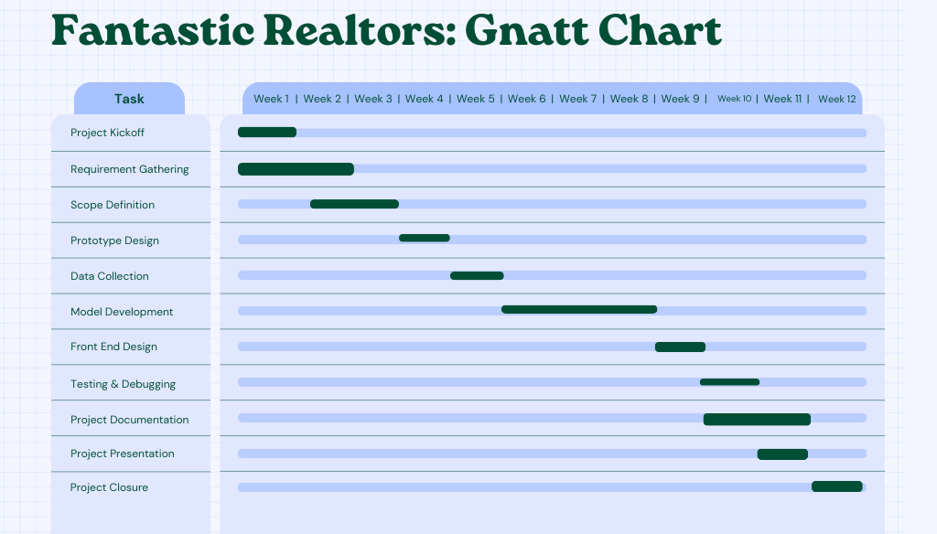

### **5.2 Development Schedule**

* **Week 1-2**: Project Kickoff, Stakeholder Identification, and Requirement Gathering.
* **Week 2-3**: Define project scope, finalize WBS, and create the Gantt Chart.
* **Week 4-5**: Data Collection, Prototype Design.
* **Week 6-8**: Model Development, Web Application Development.
* **Week 9-10**: Front-End Design, Integration, Quality Assurance, Testing and Debugging.
* **Week 10-12**: Final Testing, Documentation, Presentation, and Project Closure.

## **6. Risk Management**

### **6.1 Risk Register**

|  |  |  |  |
| --- | --- | --- | --- |
| **Risk** | **Likelihood** | **Impact** | **Mitigation Strategy** |
| Data Availability Issues | Medium | Medium | Locate various data sources and maintain alternative datasets. |
| Model Accuracy Concerns | Low | Medium | An iterative evaluation of models and adjustment. |
| Development Delays | Low | Medium | Conduct regular progress evaluations and change the timeline as appropriate. |
| Security Vulnerabilities | Medium | High | Implement protection standards and conduct frequent assessments. |

### **6.2 Risk Mitigation Plan**

* **Data Availability Issues**: Manage backup datasets and check the integrity of data early in the project.
* **Model Accuracy Concerns**: Cross-validation and hyperparameter adjustment can increase the precision of models.
* **Development Delays**: Divide work into smaller, more manageable parts and track progress regularly.
* **Security Vulnerabilities**: Incorporate security checks across the development procedure and carry out testing.

## **7. Monitor and Control – Anthony**

### **7.1 Change Control Process**

* **Change Request Submission**: Any team member can submit a change request.
* **Impact Analysis**: The project manager assesses the impact of the change on the project scope, schedule, and resources.
* **Approval**: Changes are reviewed and approved by the team during weekly meetings.
* **Implementation**: Approved changes are implemented and documented.

## **8. Closure Plan**

### **8.1 Acceptance Criteria**

* **Successful Model Deployment**: The machine learning model accurately predicts housing prices within an acceptable margin of error.
* **Usability Testing**: The web application passes usability tests with positive user feedback.
* **Stakeholder Sign-Off**: All deliverables are reviewed and approved by stakeholders.

### **8.2 Project Closure**

* **Final Documentation**: Complete and submit all project documentation, including code, reports, and user manuals.
* **Post-Project Review**: Conduct a retrospective meeting to discuss what went well and what could be improved in future projects.
* **Resource Release**: Release team members from their roles and archive project materials.

## **9. Project Design**

### **9.1 Front-End Prototype**

* **Design Sketches**: Attach hand-drawn sketches or digital prototypes of the web application interface. These should include key screens such as the homepage, data input forms, and data visualization pages.
* **Wireframes**: Create wireframes using a design tool like Figma or Sketch, showing the layout and structure of the application.

### **9.2 Usability Principles**

* **Ease of Navigation**: The design will include clear navigation paths, making it easy for users to move between different sections of the application.
* **Intuitive Layout**: The interface will follow a logical structure, with important features prominently displayed.
* **Responsive Design**: The application will be designed to work seamlessly on various devices, including desktops, tablets, and smartphones.
* **Accessibility**: The design will adhere to accessibility guidelines, ensuring that users with disabilities can effectively interact with the application.

# References

(REMINDER CHANGE REFERENCES TO HARVARD STYLE!)

* **Zillow Research. (2023).** "Understanding Housing Market Trends Using Machine Learning." *Zillow Research.* Retrieved from <https://www.zillow.com/research/>.
* **Kok, N., & Jennen, M. (2012).** "The Impact of Energy Labels and Accessibility on Office Rents." *Energy Policy,* 46, 98-106. Available at <https://doi.org/10.1016/j.enpol.2012.03.045>.
* **Li, Y., & Shen, Y. (2020).** "Predicting Housing Prices with Machine Learning: A Comparative Study of Multiple Regression Models." *Journal of Real Estate Research,* 42(3), 1-14. Available at <https://www.jstor.org/stable/44291140>.
* **Van Dijk, M., & Francke, M. (2017).** "The Predictive Power of Real Estate Market Sentiment." *Journal of Housing Economics,* 38, 25-41. Available at <https://doi.org/10.1016/j.jhe.2017.04.001>.
* **Zhou, W., & Wang, H. (2019).** "A Comprehensive Survey on Housing Price Prediction Using Machine Learning Techniques." *International Journal of Housing Markets and Analysis,* 12(4), 601-622. Available at <https://doi.org/10.1108/IJHMA-11-2018-0095>.